Tachometer
# Source: AI Source: Provided by: [Data Path: Persons Table -> ID Column: 1, Name_En Column: Motasem Essam] -> From: [ChatGPT] on [7/17/2026]
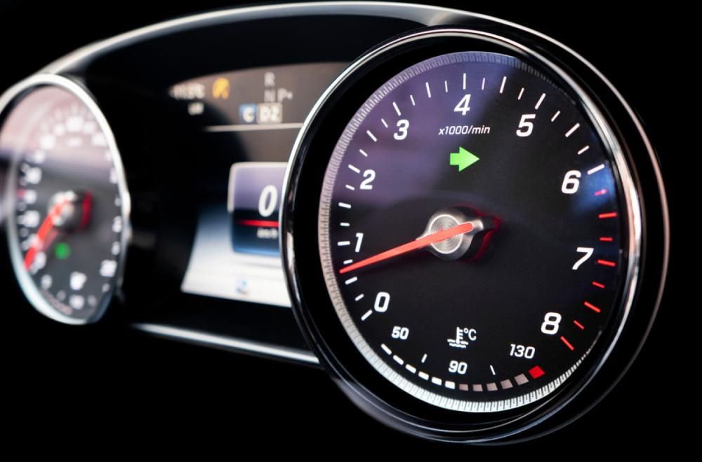
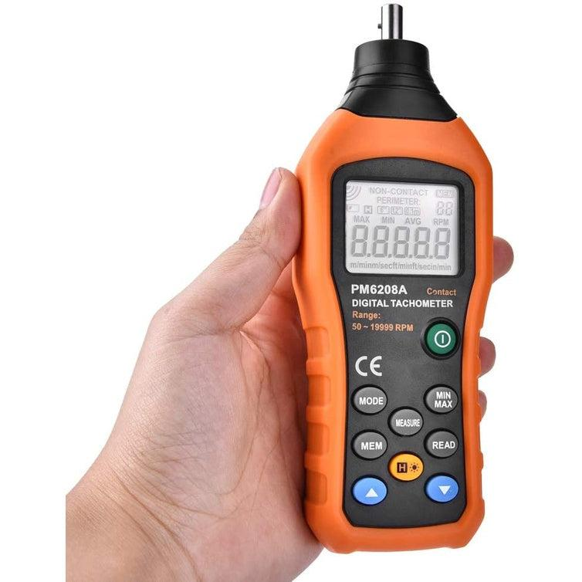
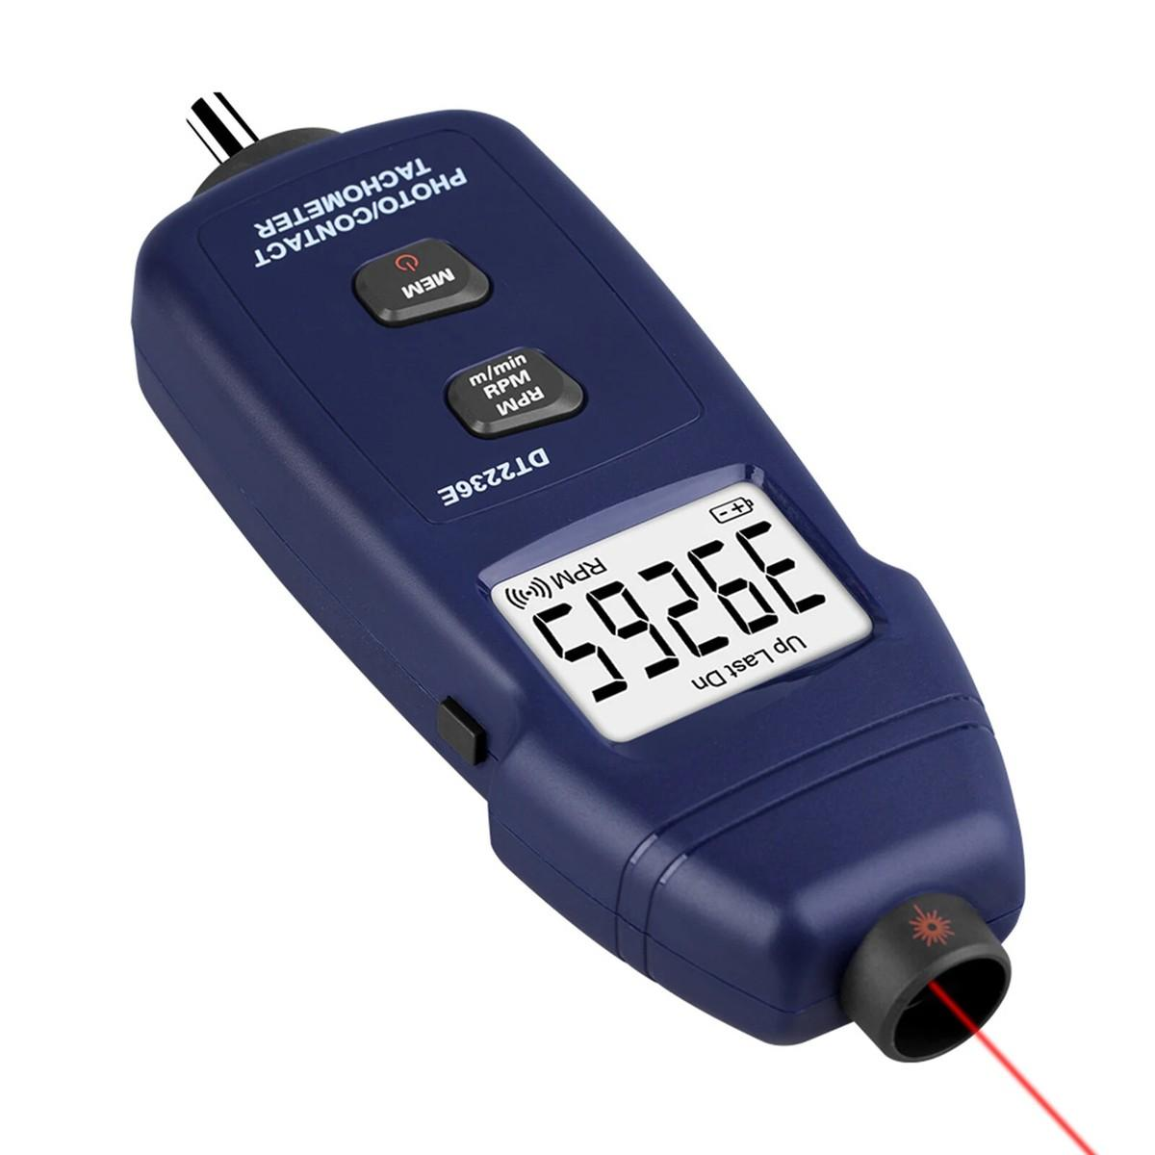
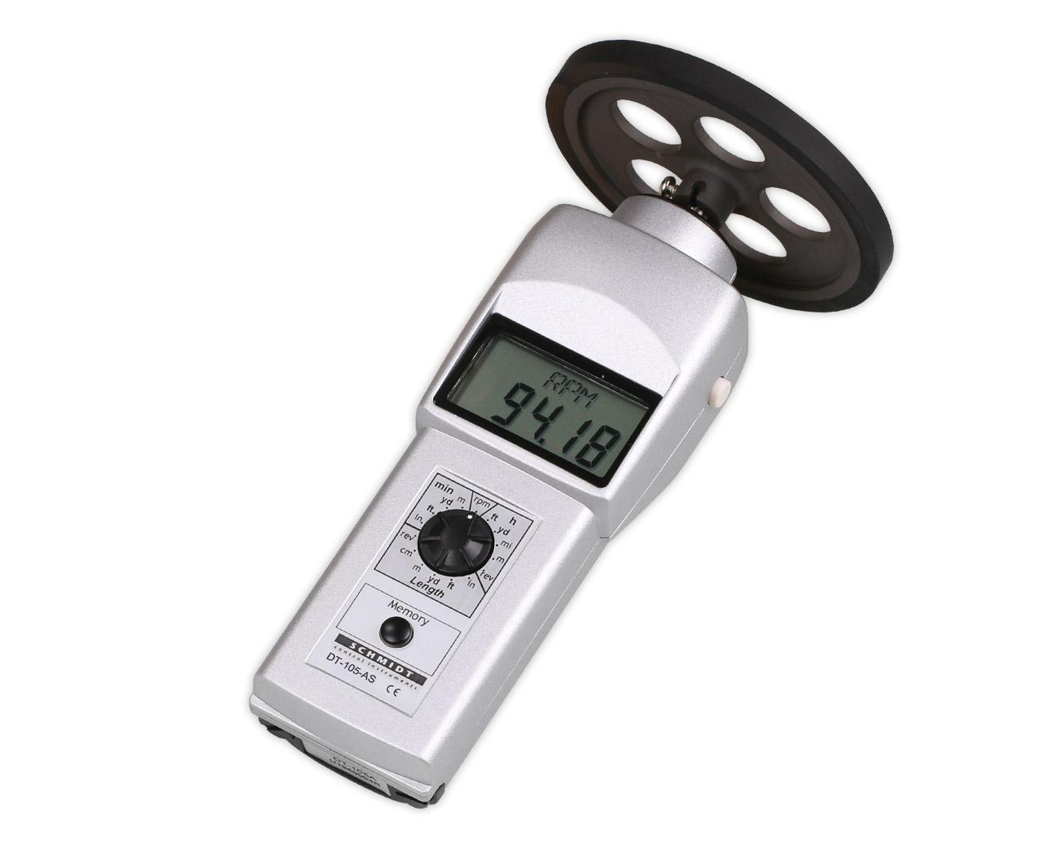
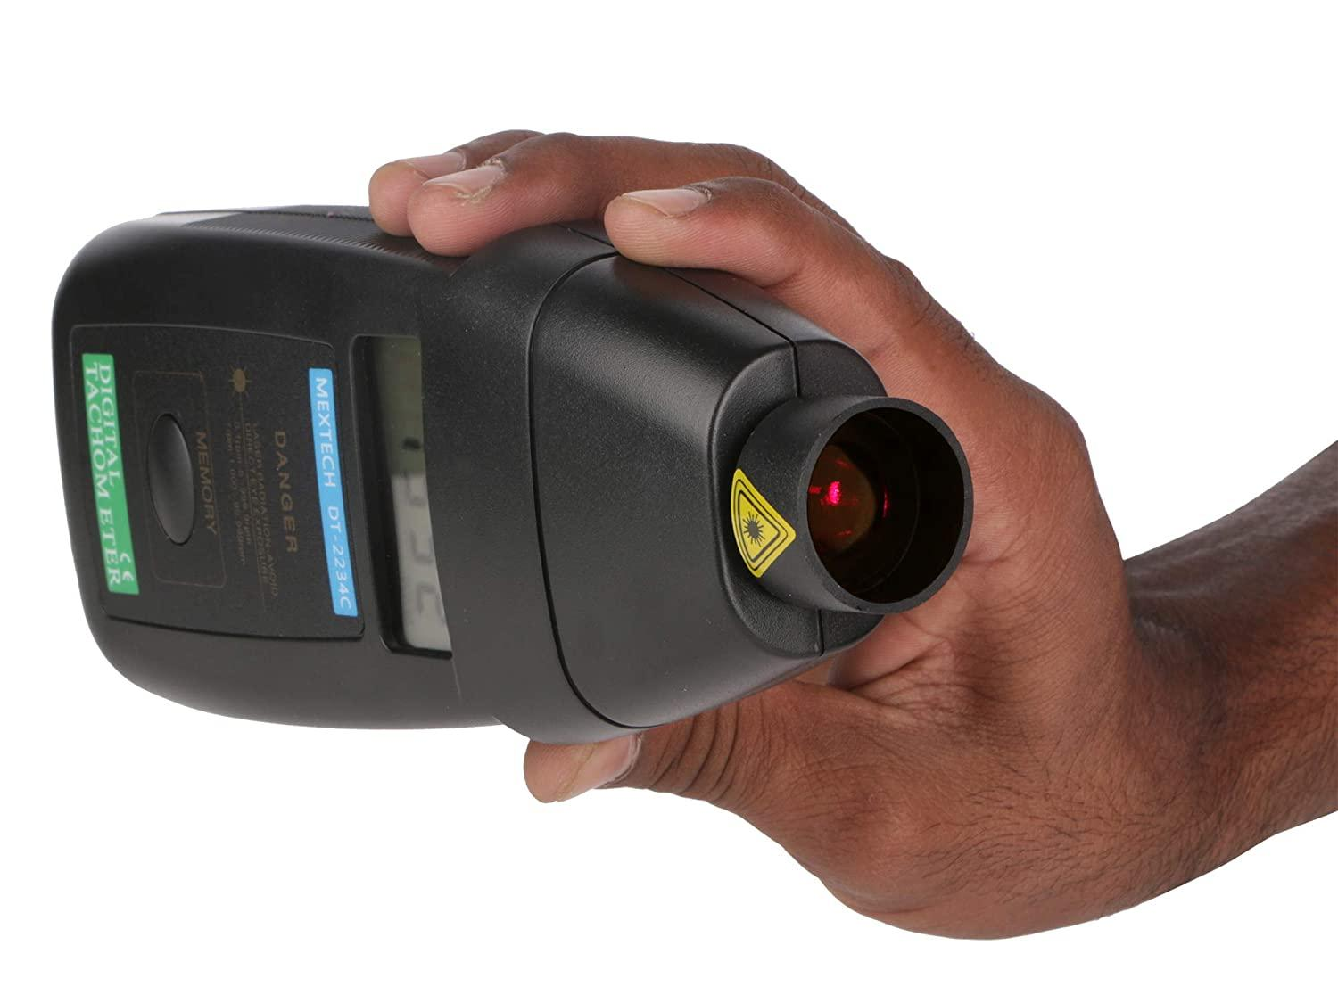
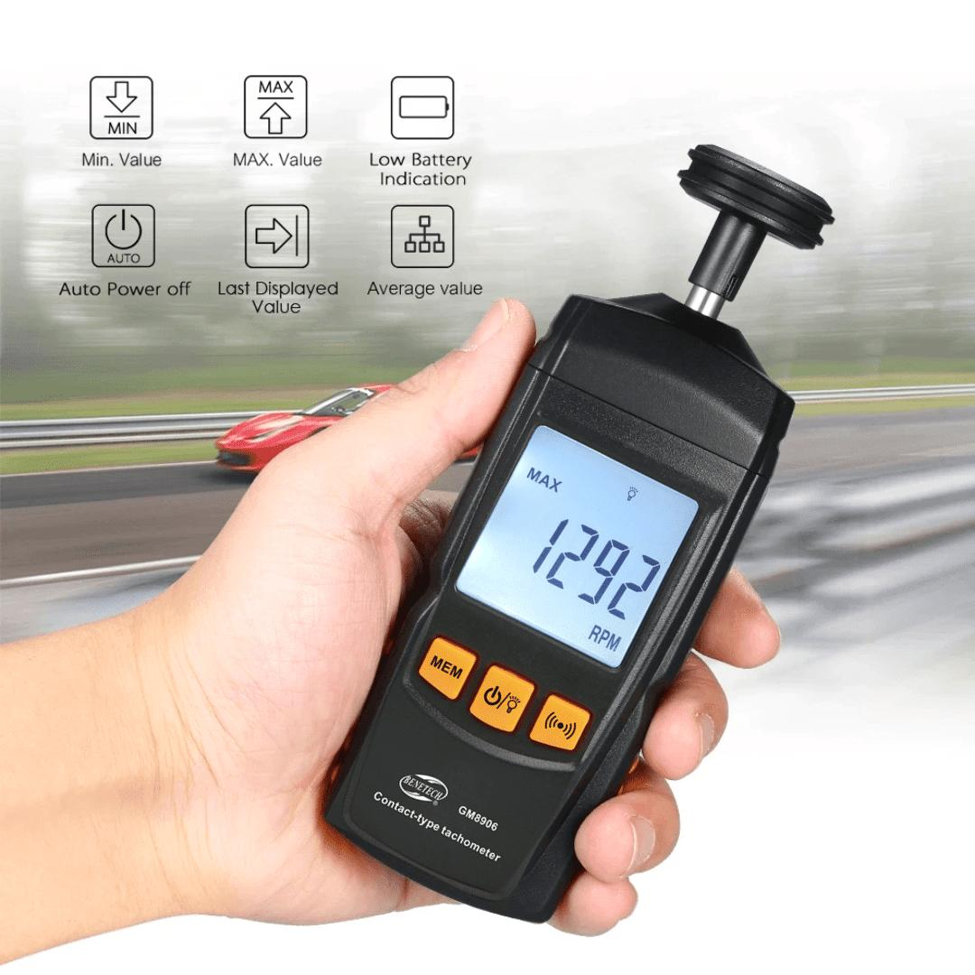
A Tachometer is a speed-measuring instrument that measures the rotational speed of a rotating shaft, engine, motor, wheel, turbine, or other rotating component. Unlike a speedometer, which measures linear speed (such as km/h or mph), a tachometer measures rotational speed, usually expressed in revolutions per minute (RPM).
Tachometers are widely used in automobiles, motorcycles, aircraft, ships, manufacturing, laboratories, electric motors, generators, pumps, fans, turbines, and maintenance applications.

Definition
# Source: AI Source: Provided by: [Data Path: Persons Table -> ID Column: 1, Name_En Column: Motasem Essam] -> From: [ChatGPT] on [7/17/2026]
A Tachometer is an instrument used to measure the rotational speed of a rotating object, typically expressed in revolutions per minute (RPM).

Purpose
# Source: AI Source: Provided by: [Data Path: Persons Table -> ID Column: 1, Name_En Column: Motasem Essam] -> From: [ChatGPT] on [7/17/2026]
A tachometer is used to:
- Measure engine speed.
- Measure motor speed.
- Monitor rotating machinery.
- Optimize engine performance.
- Prevent engine overspeed.
- Support preventive maintenance.
- Measure turbine and generator speed.
- Monitor industrial equipment.

Principle of Operation
# Source: AI Source: Provided by: [Data Path: Persons Table -> ID Column: 1, Name_En Column: Motasem Essam] -> From: [ChatGPT] on [7/17/2026]
The operating principle depends on the tachometer type.
Mechanical Tachometer
A rotating cable transmits shaft rotation to gears and a pointer mechanism.
Electronic Tachometer
Electronic sensors detect rotational pulses and convert them into RPM.
Optical Tachometer
A laser or infrared beam reflects from a marked rotating surface to determine rotational speed.
Contact Tachometer
A rotating wheel or probe physically contacts the rotating shaft to determine RPM.

Main Components
# Source: AI Source: Provided by: [Data Path: Persons Table -> ID Column: 1, Name_En Column: Motasem Essam] -> From: [ChatGPT] on [7/17/2026]
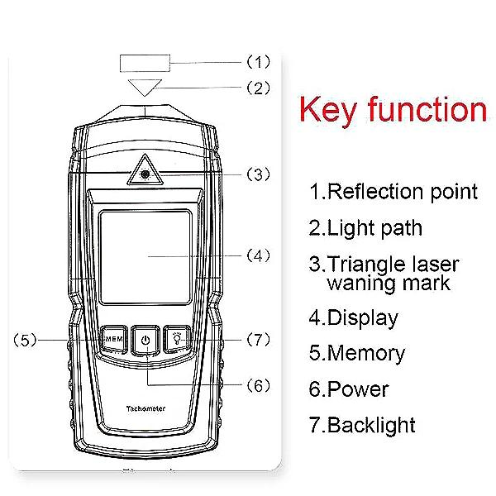
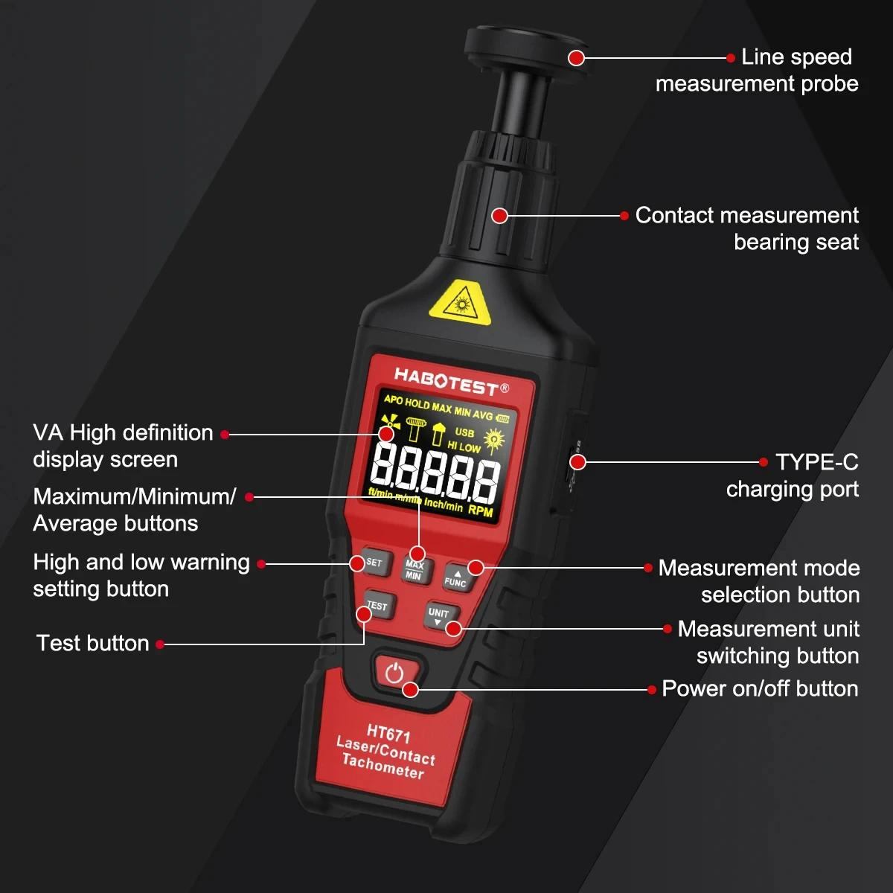
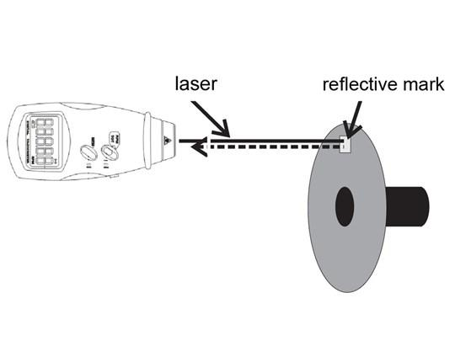
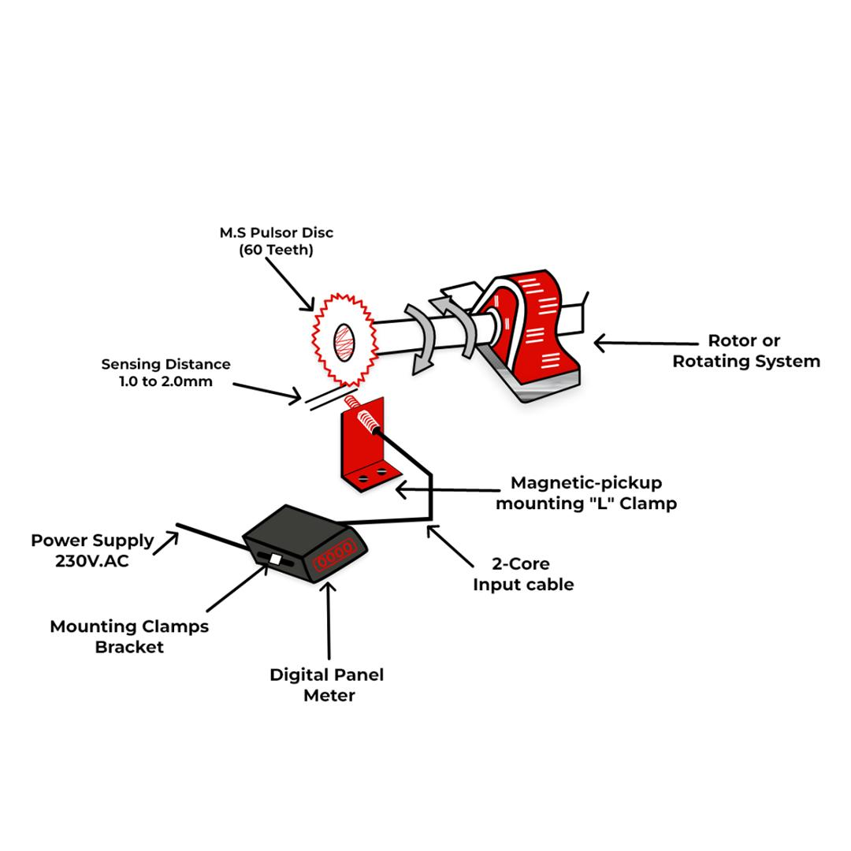
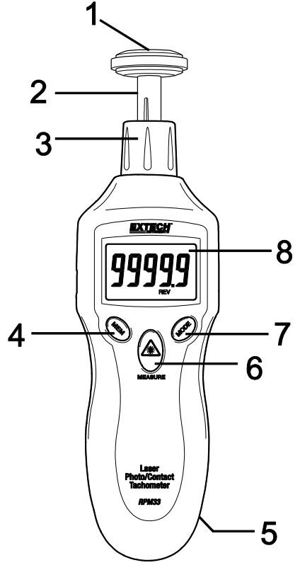
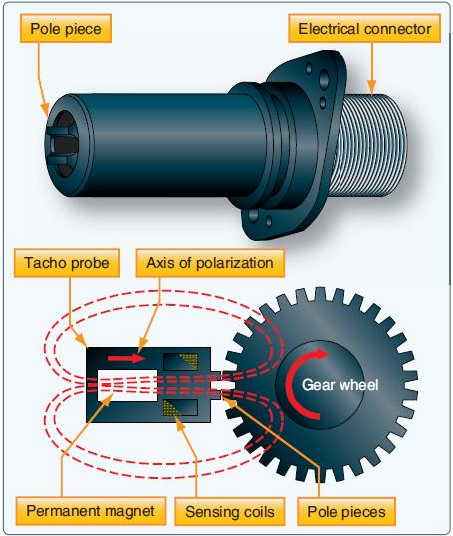
A typical tachometer consists of:
- Speed sensor
- Electronic processor
- Display (analog or digital)
- Pointer (analog models)
- Measurement probe or laser (depending on type)
- Power source

Types of Tachometers

1. Mechanical Tachometer
# Source: AI Source: Provided by: [Data Path: Persons Table -> ID Column: 1, Name_En Column: Motasem Essam] -> From: [ChatGPT] on [7/17/2026]
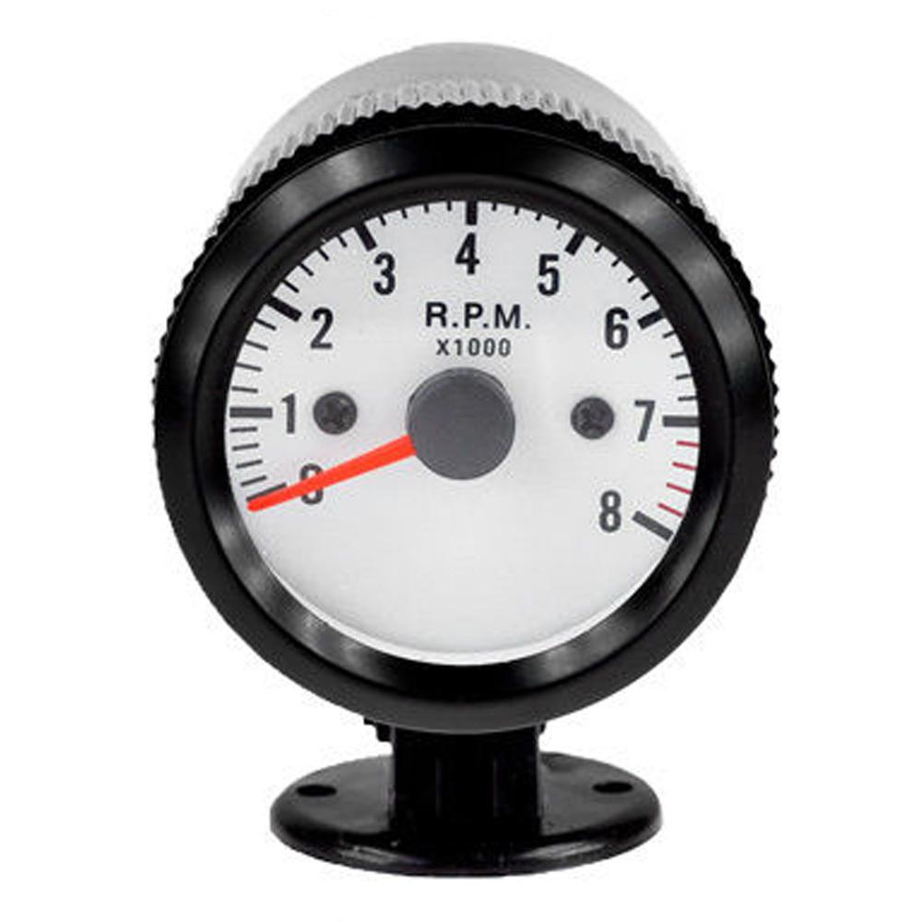
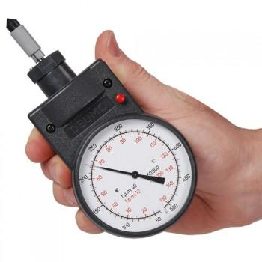
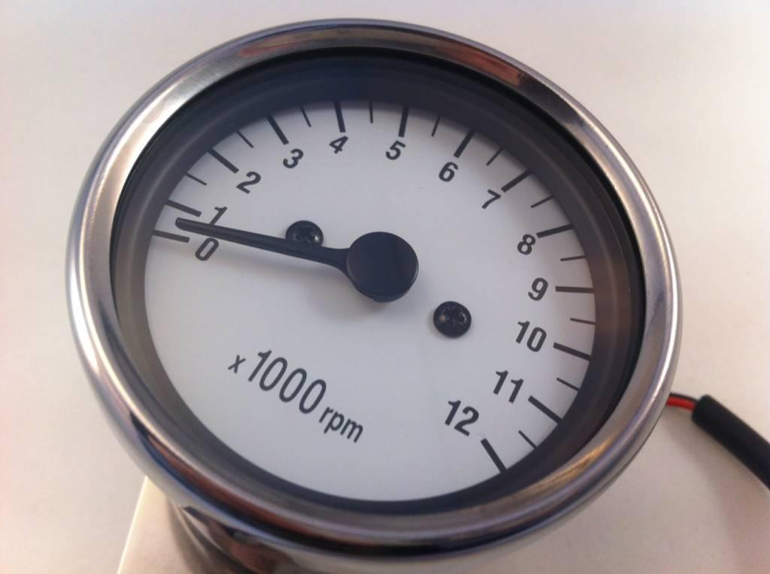
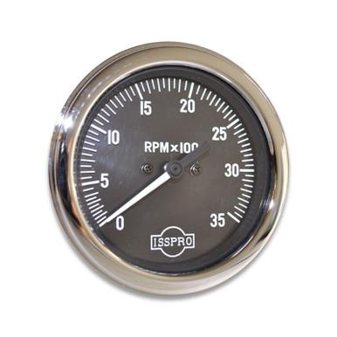
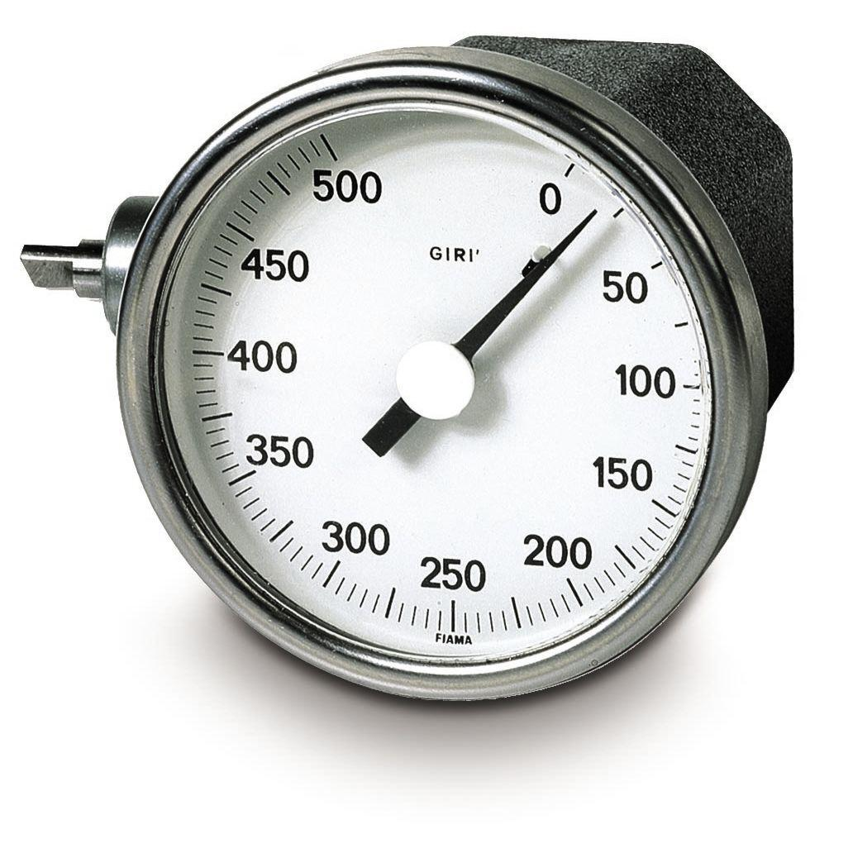
Description
Uses gears and a rotating cable connected to the engine or shaft.
Applications
- Vintage automobiles
- Older industrial equipment

2. Electronic Tachometer
# Source: AI Source: Provided by: [Data Path: Persons Table -> ID Column: 1, Name_En Column: Motasem Essam] -> From: [ChatGPT] on [7/17/2026]
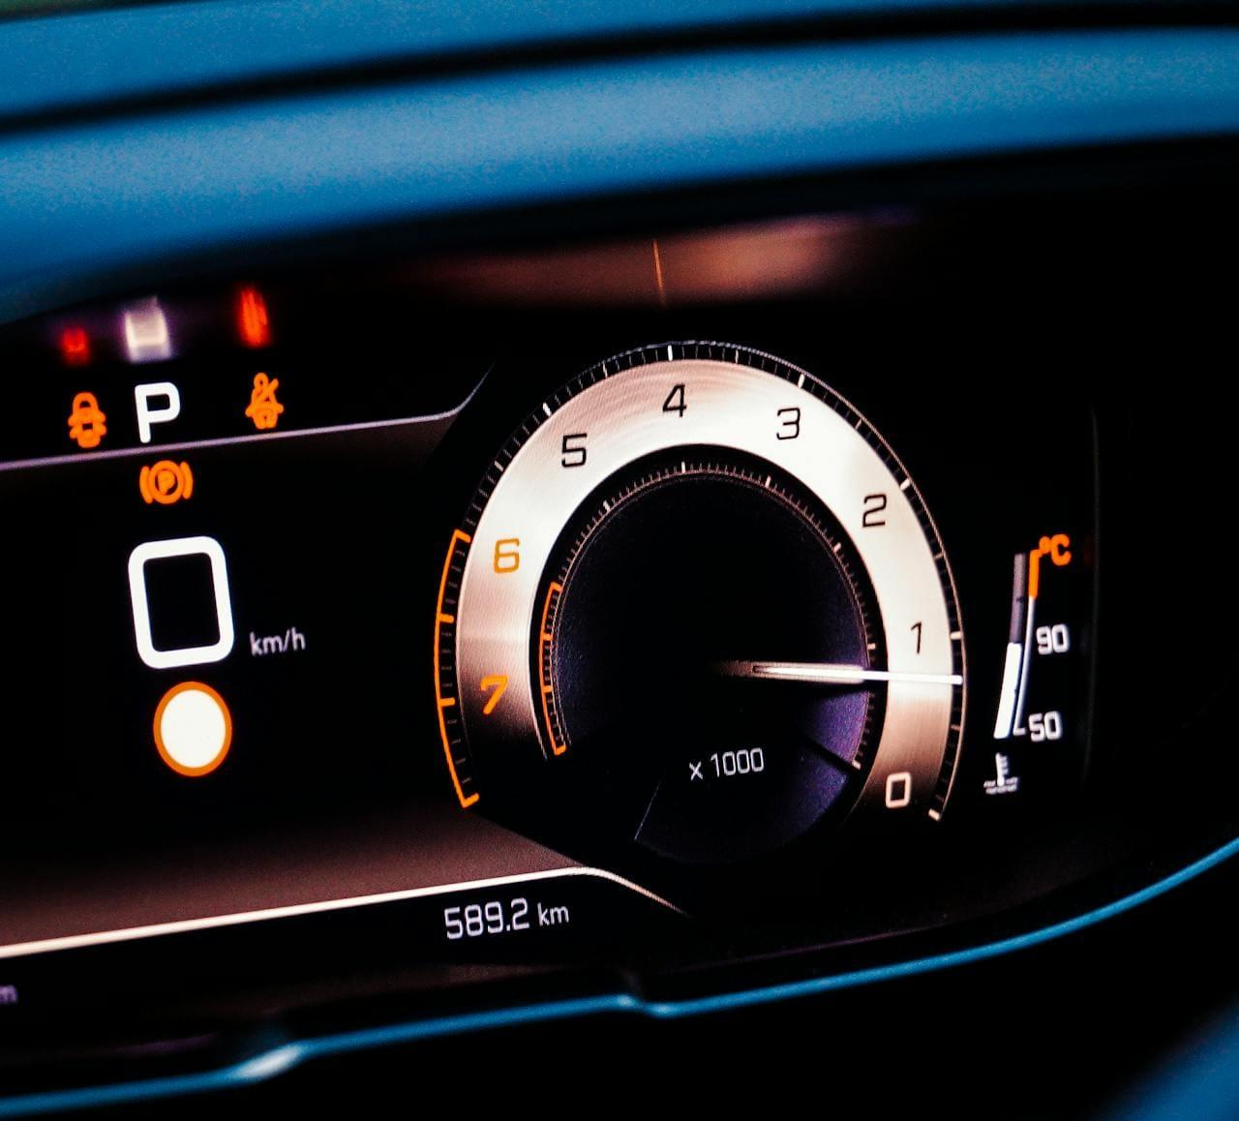
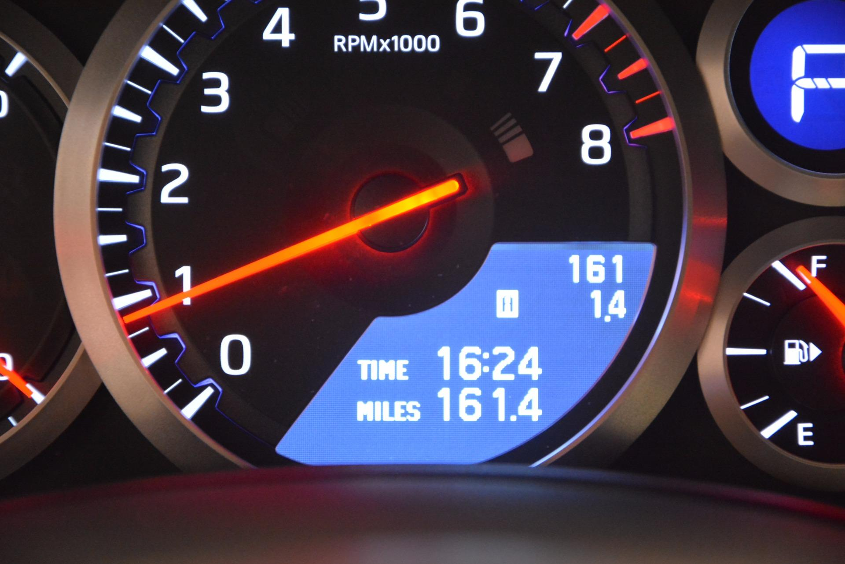
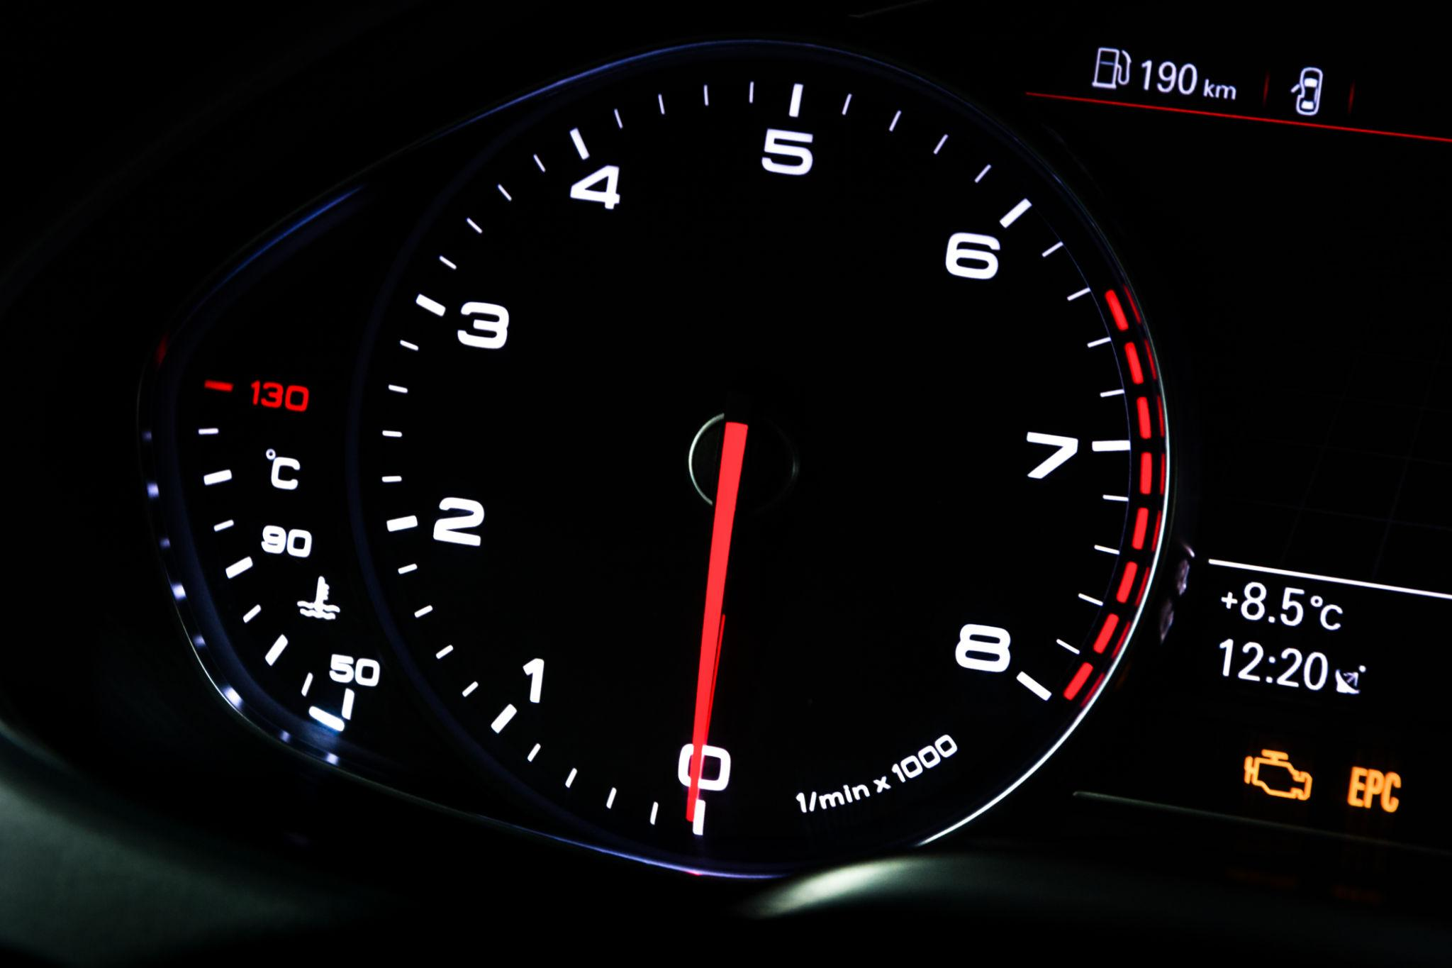
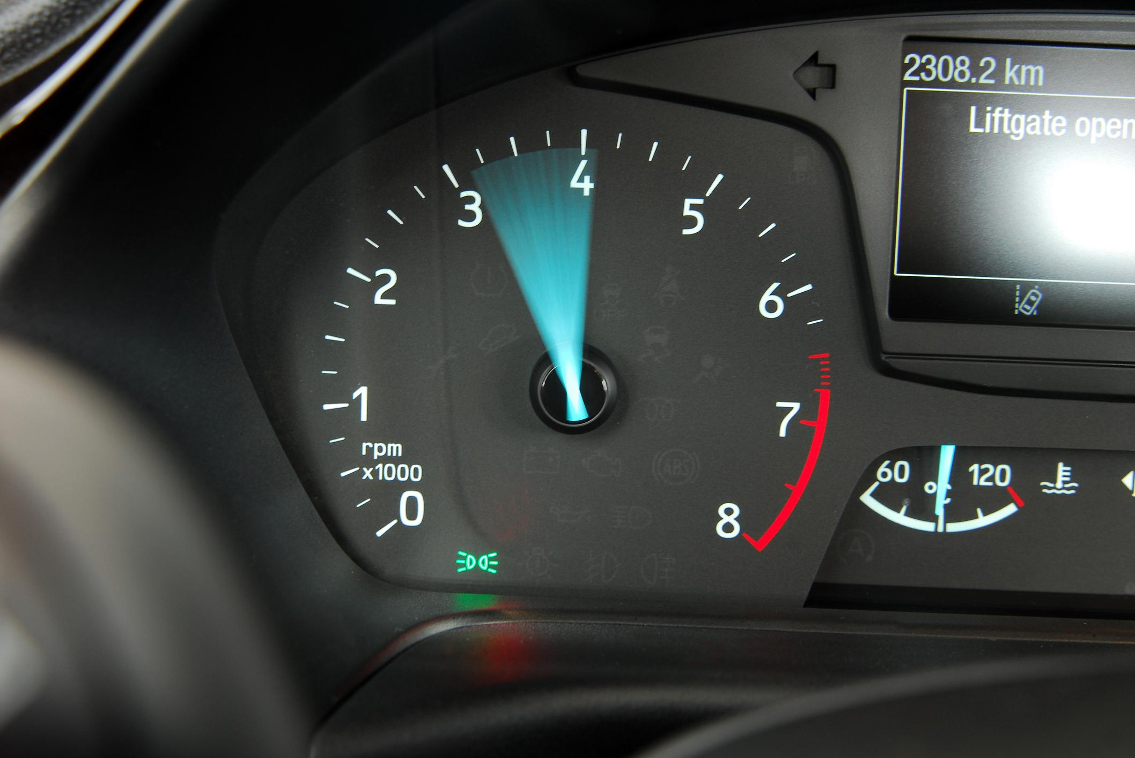
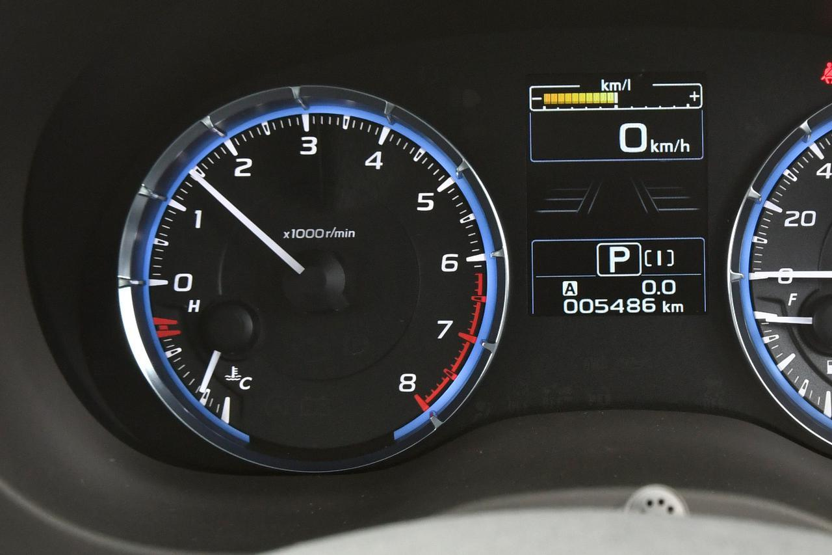
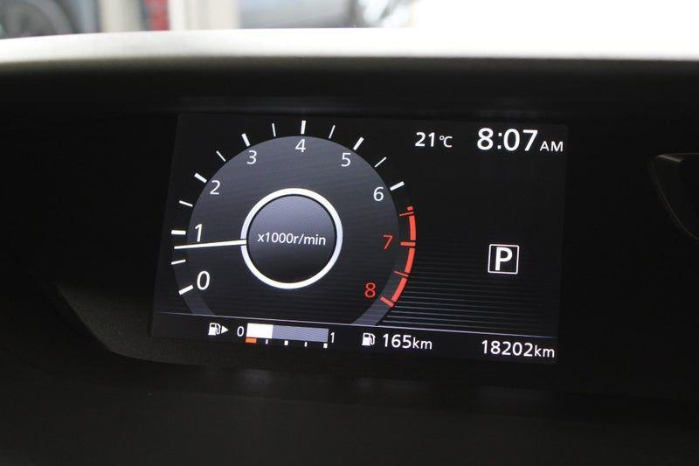
Description
Measures rotational speed using electrical pulses from sensors.
Applications
- Modern automobiles
- Motorcycles
- Electric motors

3. Digital Tachometer
# Source: AI Source: Provided by: [Data Path: Persons Table -> ID Column: 1, Name_En Column: Motasem Essam] -> From: [ChatGPT] on [7/17/2026]
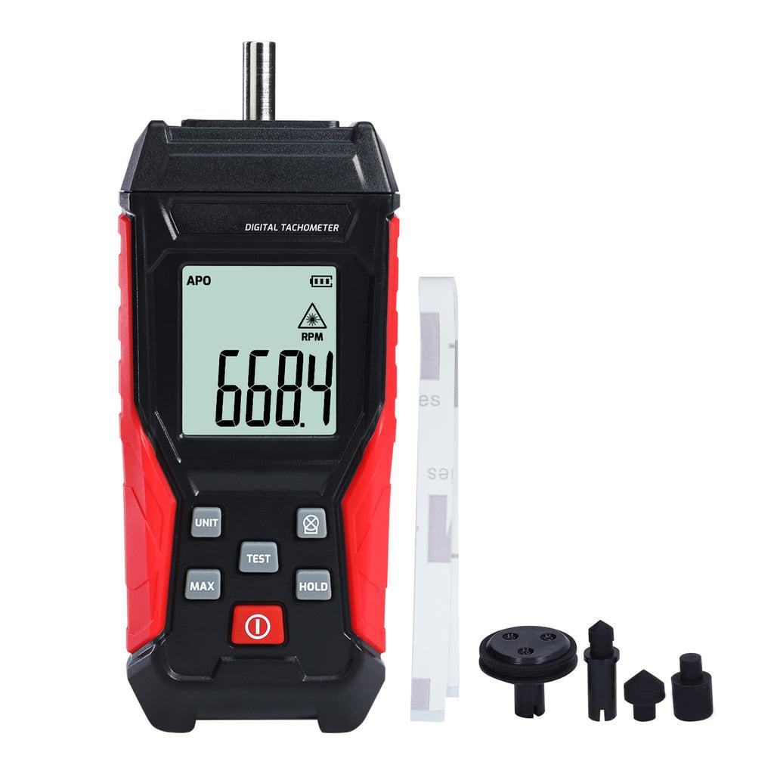
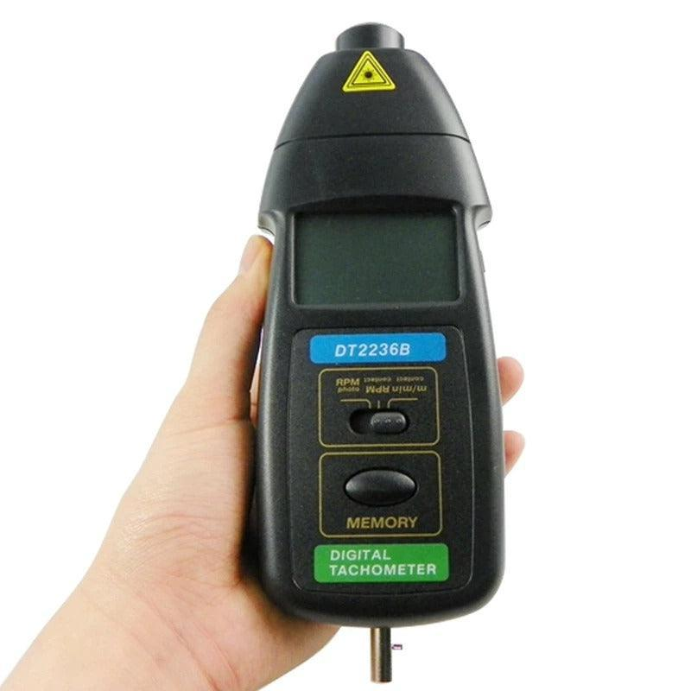

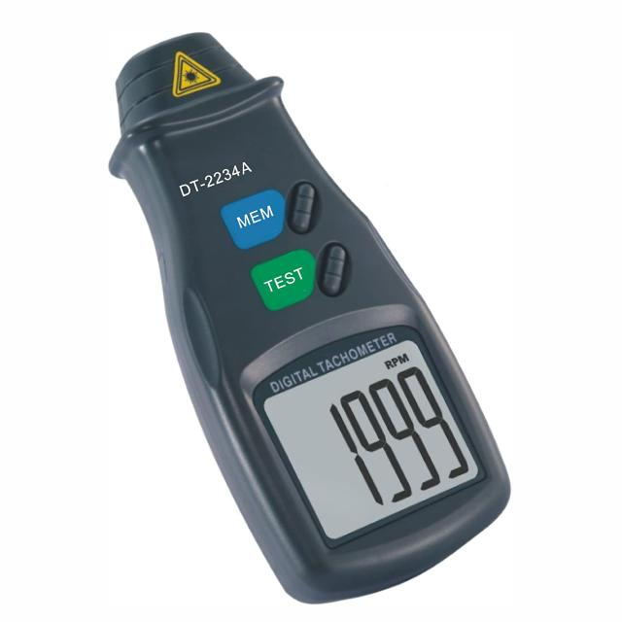
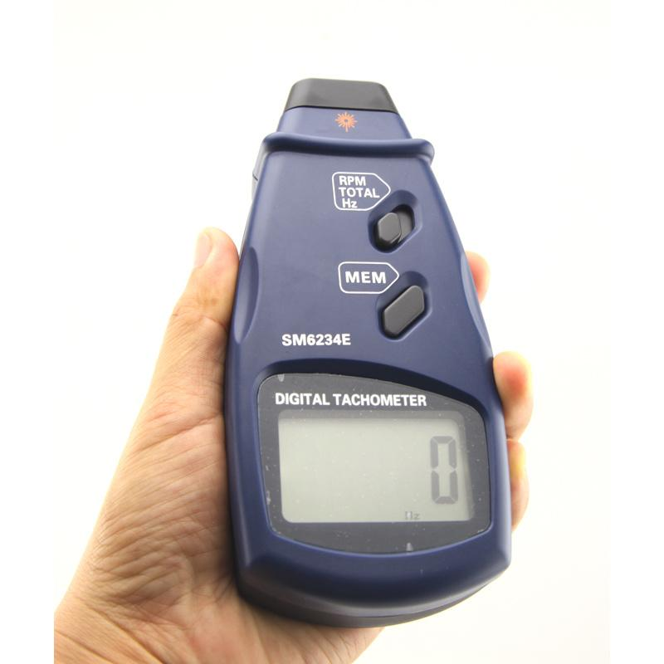
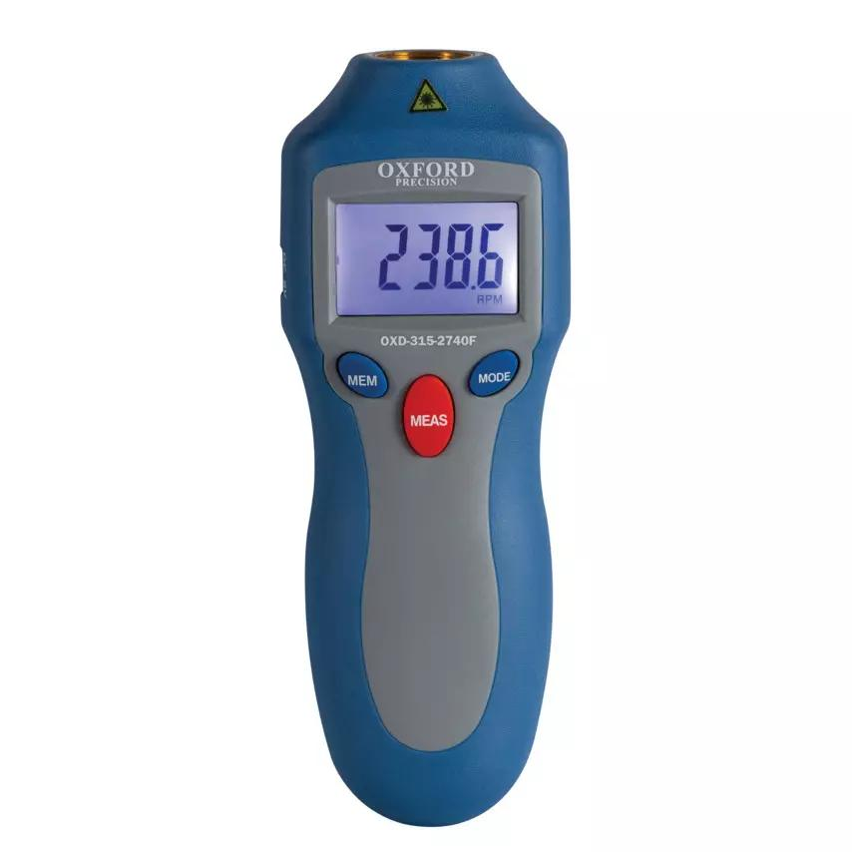
Description
Displays RPM numerically using electronic circuitry.
Applications
- Industrial maintenance
- Laboratories
- Motor testing

4. Optical (Laser) Tachometer
# Source: AI Source: Provided by: [Data Path: Persons Table -> ID Column: 1, Name_En Column: Motasem Essam] -> From: [ChatGPT] on [7/17/2026]


Description
Measures RPM without physical contact using a laser beam reflected from reflective tape.
Features
- Non-contact measurement
- High accuracy
- Safe for moving machinery
Applications
- Industrial maintenance
- Rotating machinery
- Research laboratories

5. Contact Tachometer
# Source: AI Source: Provided by: [Data Path: Persons Table -> ID Column: 1, Name_En Column: Motasem Essam] -> From: [ChatGPT] on [7/17/2026]
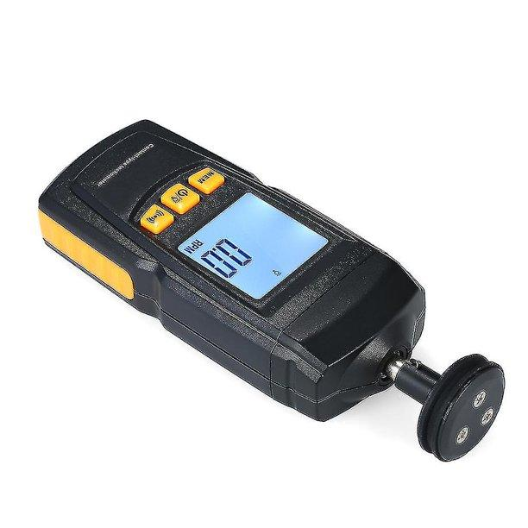
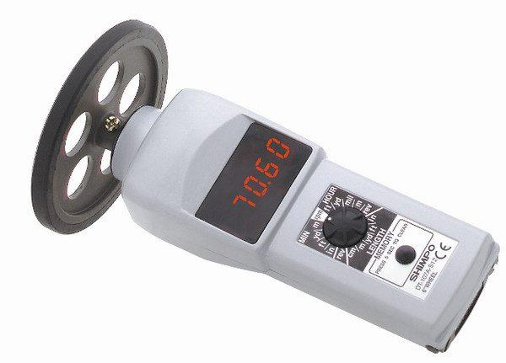
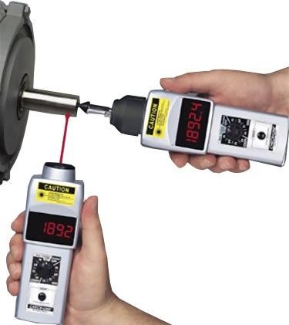
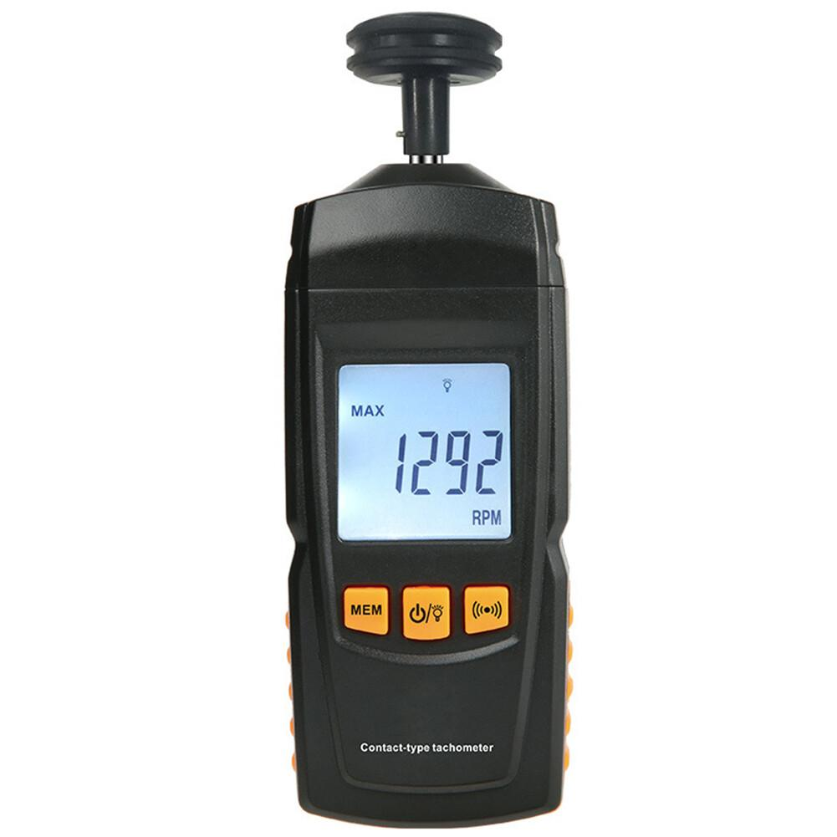
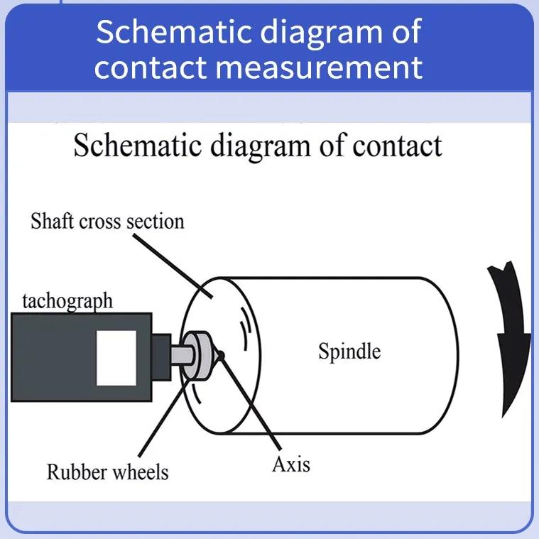
Description
Measures RPM by touching the rotating shaft with a rubber wheel or probe.
Applications
- Motors
- Shafts
- Rollers
- Conveyor systems

Measuring Units
# Source: AI Source: Provided by: [Data Path: Persons Table -> ID Column: 1, Name_En Column: Motasem Essam] -> From: [ChatGPT] on [7/17/2026]
Tachometers commonly display:
- Revolutions per Minute (RPM or r/min)
Some specialized models may also display:
- Revolutions per Second (RPS)
- Angular velocity (rad/s)
- Surface speed (with attachments)

Measuring Range
# Source: AI Source: Provided by: [Data Path: Persons Table -> ID Column: 1, Name_En Column: Motasem Essam] -> From: [ChatGPT] on [7/17/2026]
The measuring range depends on the tachometer type.
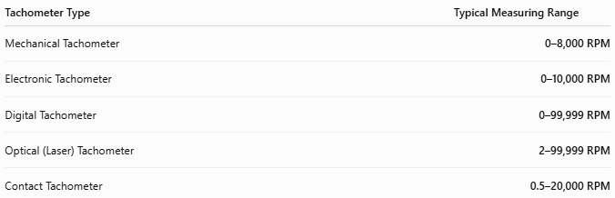
Tachometer Type | Typical Measuring Range
Mechanical Tachometer | 0–8,000 RPM
Electronic Tachometer | 0–10,000 RPM
Digital Tachometer | 0–99,999 RPM
Optical (Laser) Tachometer | 2–99,999 RPM
Contact Tachometer | 0.5–20,000 RPM

Resolution
# Source: AI Source: Provided by: [Data Path: Persons Table -> ID Column: 1, Name_En Column: Motasem Essam] -> From: [ChatGPT] on [7/17/2026]
Resolution is the smallest change in rotational speed that can be displayed.
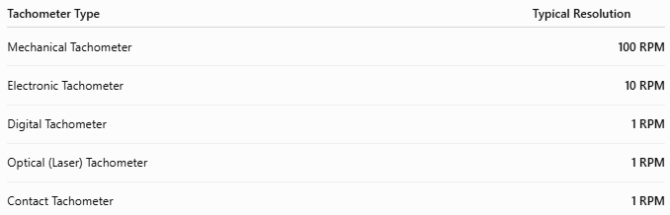
Tachometer Type | Typical Resolution
Mechanical Tachometer | 100 RPM
Electronic Tachometer | 10 RPM
Digital Tachometer | 1 RPM
Optical (Laser) Tachometer | 1 RPM
Contact Tachometer | 1 RPM

Accuracy
# Source: AI Source: Provided by: [Data Path: Persons Table -> ID Column: 1, Name_En Column: Motasem Essam] -> From: [ChatGPT] on [7/17/2026]
Accuracy indicates how closely the displayed RPM matches the actual rotational speed.
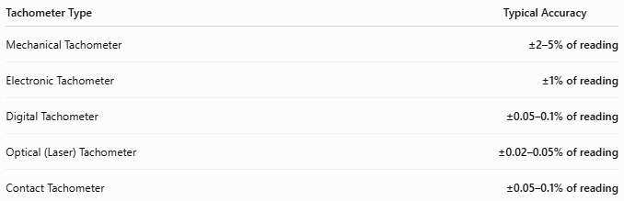
Tachometer Type | Typical Accuracy
Mechanical Tachometer | ±2–5% of reading
Electronic Tachometer | ±1% of reading
Digital Tachometer | ±0.05–0.1% of reading
Optical (Laser) Tachometer | ±0.02–0.05% of reading
Contact Tachometer | ±0.05–0.1% of reading
Notes
- Mechanical tachometers generally have the lowest accuracy due to mechanical wear and friction.
- Electronic tachometers provide improved accuracy by using electronic pulse detection.
- Digital tachometers offer high precision and are commonly used in maintenance and laboratory applications.
- Optical (laser) tachometers are among the most accurate because they measure without physical contact, reducing mechanical errors.
- Contact tachometers provide high accuracy but require firm contact with the rotating object; slippage between the probe and shaft can introduce measurement errors.

How to Use a Tachometer
# Source: AI Source: Provided by: [Data Path: Persons Table -> ID Column: 1, Name_En Column: Motasem Essam] -> From: [ChatGPT] on [7/17/2026]
- Turn the instrument on.
- Select the measurement mode (contact or non-contact, if applicable).
- Position the probe or laser at the rotating object.
- Allow the reading to stabilize.
- Read the RPM displayed on the screen or dial.

Example
# Source: AI Source: Provided by: [Data Path: Persons Table -> ID Column: 1, Name_En Column: Motasem Essam] -> From: [ChatGPT] on [7/17/2026]
The display reads:
2,450 RPM
Rotational speed:
2,450 revolutions per minute

Applications
# Source: AI Source: Provided by: [Data Path: Persons Table -> ID Column: 1, Name_En Column: Motasem Essam] -> From: [ChatGPT] on [7/17/2026]
Tachometers are used in:
- Automobiles
- Motorcycles
- Aircraft
- Ships
- Electric motors
- Pumps
- Turbines
- Generators
- Manufacturing
- Laboratories
- Industrial maintenance

Advantages
# Source: AI Source: Provided by: [Data Path: Persons Table -> ID Column: 1, Name_En Column: Motasem Essam] -> From: [ChatGPT] on [7/17/2026]
A tachometer:
- Provides real-time RPM measurement.
- Improves equipment performance monitoring.
- Helps prevent overspeed conditions.
- Supports predictive maintenance.
- Offers high accuracy (digital and optical models).

Limitations
# Source: AI Source: Provided by: [Data Path: Persons Table -> ID Column: 1, Name_En Column: Motasem Essam] -> From: [ChatGPT] on [7/17/2026]
A tachometer:
- Contact models require physical access.
- Optical models require a clear line of sight and reflective target.
- Mechanical models experience wear over time.
- Electronic models require power.

Sources of Error
# Source: AI Source: Provided by: [Data Path: Persons Table -> ID Column: 1, Name_En Column: Motasem Essam] -> From: [ChatGPT] on [7/17/2026]
Instrument Errors
- Calibration drift
- Sensor failure
- Mechanical wear
- Low battery

User Errors
- Incorrect probe placement
- Laser aimed at the wrong target
- Poor contact with the rotating shaft

Environmental Errors
- Excessive vibration
- Dust covering reflective tape
- Strong ambient light affecting optical sensors
- Shaft slippage (contact models)

Comparison with Other Speed Measuring Instruments
# Source: AI Source: Provided by: [Data Path: Persons Table -> ID Column: 1, Name_En Column: Motasem Essam] -> From: [ChatGPT] on [7/17/2026]
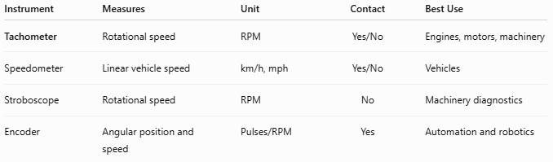
Instrument | Measures | Unit | Contact | Best Use
Tachometer | Rotational speed | RPM | Yes/No | Engines, motors, machinery
Speedometer | Linear vehicle speed | km/h, mph | Yes/No | Vehicles
Stroboscope | Rotational speed | RPM | No | Machinery diagnostics
Encoder | Angular position and speed | Pulses/RPM | Yes | Automation and robotics

Care and Maintenance
# Source: AI Source: Provided by: [Data Path: Persons Table -> ID Column: 1, Name_En Column: Motasem Essam] -> From: [ChatGPT] on [7/17/2026]
To maintain accuracy:
- Keep optical sensors clean.
- Replace batteries when needed.
- Calibrate periodically.
- Inspect contact wheels for wear.
- Store in a protective case.

Common Mistakes
# Source: AI Source: Provided by: [Data Path: Persons Table -> ID Column: 1, Name_En Column: Motasem Essam] -> From: [ChatGPT] on [7/17/2026]
- Confusing RPM with vehicle speed.
- Using the wrong measurement mode.
- Poor reflective tape placement for optical tachometers.
- Allowing contact wheels to slip.
- Measuring unstable rotating equipment.

Key Points
# Source: AI Source: Provided by: [Data Path: Persons Table -> ID Column: 1, Name_En Column: Motasem Essam] -> From: [ChatGPT] on [7/17/2026]
- A Tachometer measures rotational speed, not linear speed.
- Common types:
  - Mechanical Tachometer
  - Electronic Tachometer
  - Digital Tachometer
  - Optical (Laser) Tachometer
  - Contact Tachometer
- Primary unit:
  - Revolutions per Minute (RPM)
- Optical tachometers provide the highest accuracy for non-contact measurements.
- Tachometers are essential for automotive, industrial, aerospace, laboratory, and maintenance applications.

Conclusion
# Source: AI Source: Provided by: [Data Path: Persons Table -> ID Column: 1, Name_En Column: Motasem Essam] -> From: [ChatGPT] on [7/17/2026]
A Tachometer is a precision instrument used to measure the rotational speed of engines, motors, shafts, and other rotating machinery. By displaying speed in revolutions per minute (RPM), it enables operators and technicians to monitor equipment performance, prevent overspeed conditions, and support preventive maintenance. From traditional mechanical designs to modern laser-based digital instruments, tachometers remain indispensable tools across automotive, industrial, manufacturing, aerospace, and scientific applications.

